***PAAREES PERFUMES***

***Christian Diors***

***FOR WOMEN***

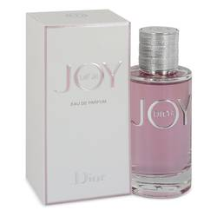

# *Dior Joy*

***Description:***

Dior Joy by Christian Dior Perfume. Released in 2018, Dior Joy is an energetic, citrus-woody fragrance for women created by perfumer Francois Demachy. The top notes are zesty citruses bergamot and mandarin orange. The middle heart notes are florals, with sweet heady jasmine and Grasse rose. The base is warm and soft, with white musk, creamy sandalwood, cedar, and patchouli. Pleasantly sweet and floral fresh, this fragrance is meant to symbolize joy and is a great daytime scent for warmer months.  
  
This internationally famous fashion brand came to being in 1947 at the hand of Christian Dior, his “New Look” styles and “Miss Dior” fragrance all coming to light in the same year. His success in the ten years until his death, and in the years since, has been huge and influential in both the fashion and the perfume worlds. More than 225 perfumes and colognes have been produced under the designer name, in collaboration with many top perfumers.